DESIGN AND ANALYSIS OF ALGORITHM LAB
Python Programs with VS Code Terminal Outputs
BCS-553 | B.Tech III Year | 5th Semester
Prepared according to the 19 experiments listed in the uploaded DAA Lab practical sheet. Each experiment contains Python code, sample terminal output, and time-complexity information where the practical asks for analysis.

1. Recursive Linear Search
Python Code
def linear_search(arr, target, i=0):
if i == len(arr):
return -1
if arr[i] == target:
return i
return linear_search(arr, target, i + 1)
arr = [105, 203, 117, 450, 321]
target = 450
pos = linear_search(arr, target)
print("Ticket IDs:", arr)
if pos != -1:
print("Ticket", target, "found at index", pos)
else:
print("Ticket does not exist.")
print("Best Case: O(1)")
print("Average Case: O(n)")
print("Worst Case: O(n)")
VS Code Terminal Output
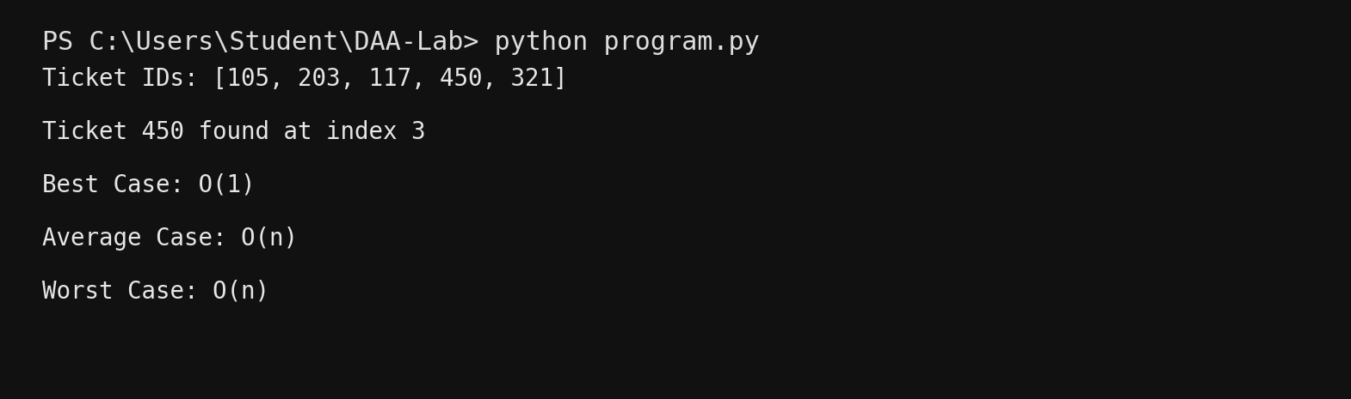

2. Recursive Binary Search
Python Code
def binary_search(arr, target, low, high):
if low > high:
return -1
mid = (low + high) // 2
if arr[mid] == target:
return mid
elif target < arr[mid]:
return binary_search(arr, target, low, mid - 1)
else:
return binary_search(arr, target, mid + 1, high)
prices = [100, 150, 200, 250, 300, 350, 400]
target = 300
pos = binary_search(prices, target, 0, len(prices) - 1)
print("Sorted prices:", prices)
if pos != -1:
print("Price", target, "found at index", pos)
else:
print("Product does not exist.")
print("Best/Average/Worst Case: O(log n)")
print("The array must be sorted for binary search.")
VS Code Terminal Output
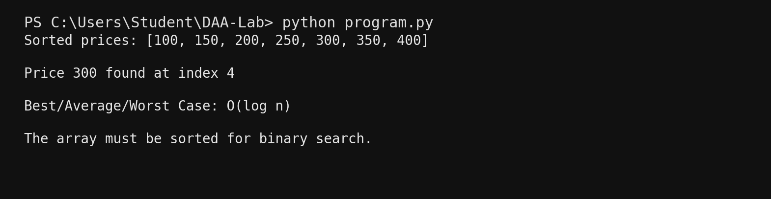

3. Bubble Sort
Python Code
def bubble_sort(arr):
n = len(arr)
for i in range(n - 1):
swapped = False
for j in range(n - 1 - i):
if arr[j] > arr[j + 1]:
arr[j], arr[j + 1] = arr[j + 1], arr[j]
swapped = True
if not swapped:
break
distances = [320, 280, 350, 300, 270]
bubble_sort(distances)
print("Sorted jump distances:", distances)
print("Best Case: O(n), 1 pass when already sorted")
print("Average Case: O(n^2)")
print("Worst Case: O(n^2), n-1 passes for reverse order")
VS Code Terminal Output
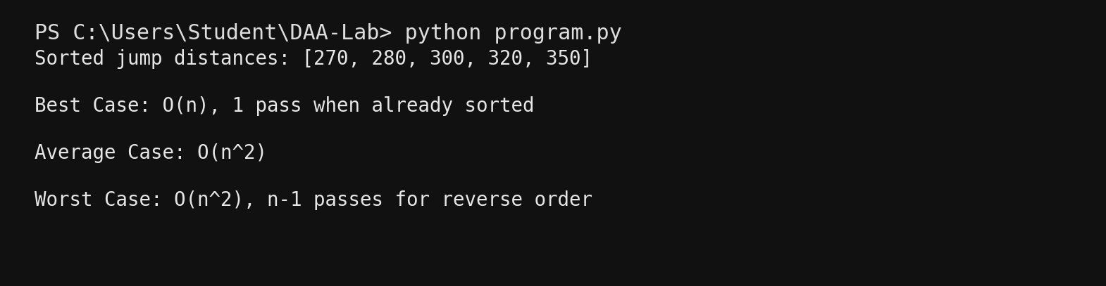

4. Selection Sort
Python Code
def selection_sort(arr):
swaps = 0
n = len(arr)
for i in range(n - 1):
min_index = i
for j in range(i + 1, n):
if arr[j] < arr[min_index]:
min_index = j
if min_index != i:
arr[i], arr[min_index] = arr[min_index], arr[i]
swaps += 1
return swaps
rolls = [105, 102, 110, 101, 108]
swaps = selection_sort(rolls)
print("Sorted roll numbers:", rolls)
print("Selection sort swaps:", swaps)
print("Selection Sort - Best/Average/Worst: O(n^2)")
print("Selection sort generally uses fewer swaps than bubble sort.")
VS Code Terminal Output
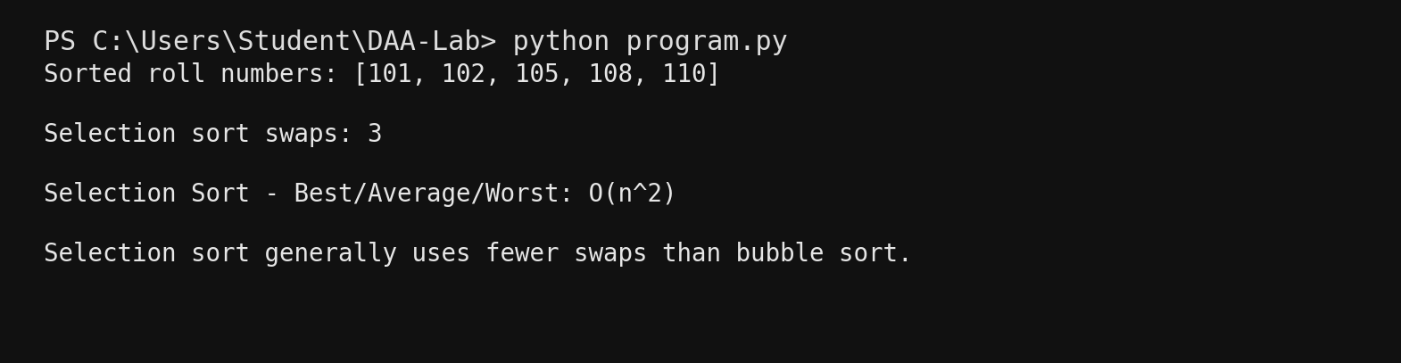

5. Insertion Sort
Python Code
def insertion_sort(arr):
for i in range(1, len(arr)):
key = arr[i]
j = i - 1
while j >= 0 and arr[j] > key:
arr[j + 1] = arr[j]
j -= 1
arr[j + 1] = key
books = [104, 101, 105, 102, 103]
insertion_sort(books)
print("Sorted book IDs:", books)
print("Best Case: O(n)")
print("Average Case: O(n^2)")
print("Worst Case: O(n^2)")
VS Code Terminal Output
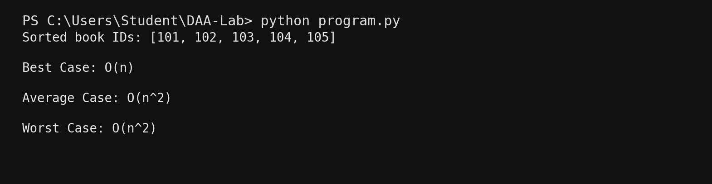

6. Quick Sort - First Element Pivot
Python Code
def quick_sort(arr):
if len(arr) <= 1:
return arr
pivot = arr[0]
left = [x for x in arr[1:] if x <= pivot]
right = [x for x in arr[1:] if x > pivot]
return quick_sort(left) + [pivot] + quick_sort(right)
fares = [450, 200, 700, 300, 550]
sorted_fares = quick_sort(fares)
print("Sorted fares:", sorted_fares)
print("Best Case: O(n log n)")
print("Average Case: O(n log n)")
print("Worst Case: O(n^2)")
print("Worst case occurs for already sorted or reverse sorted data with first-element pivot.")
VS Code Terminal Output
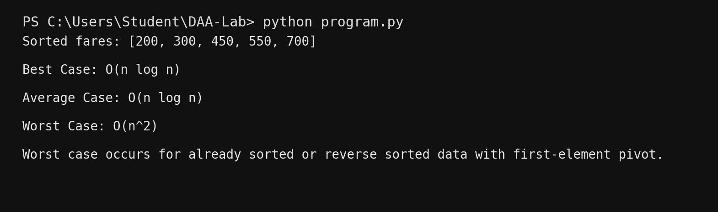

7. Quick Sort - Last Element Pivot (Lomuto)
Python Code
def partition(arr, low, high):
pivot = arr[high]
i = low - 1
for j in range(low, high):
if arr[j] <= pivot:
i += 1
arr[i], arr[j] = arr[j], arr[i]
arr[i + 1], arr[high] = arr[high], arr[i + 1]
return i + 1
def quick_sort(arr, low, high):
if low < high:
p = partition(arr, low, high)
quick_sort(arr, low, p - 1)
quick_sort(arr, p + 1, high)
times = [35, 20, 50, 25, 40]
quick_sort(times, 0, len(times) - 1)
print("Sorted delivery times:", times)
print("Best Case: O(n log n)")
print("Average Case: O(n log n)")
print("Worst Case: O(n^2)")
print("Worst case occurs for already sorted or reverse sorted data with last-element pivot.")
VS Code Terminal Output
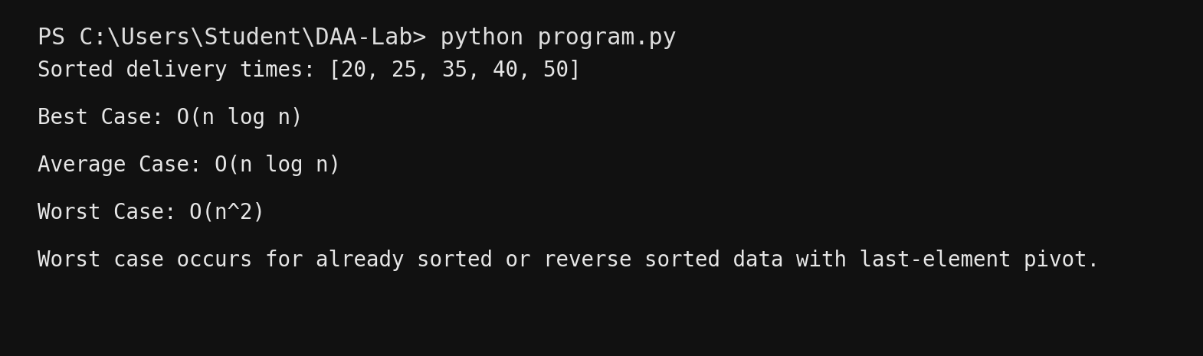

8. Heap Sort
Python Code
def heapify(arr, n, i):
largest = i
left = 2 * i + 1
right = 2 * i + 2
if left < n and arr[left] > arr[largest]:
largest = left
if right < n and arr[right] > arr[largest]:
largest = right
if largest != i:
arr[i], arr[largest] = arr[largest], arr[i]
heapify(arr, n, largest)
def heap_sort(arr):
n = len(arr)
for i in range(n // 2 - 1, -1, -1):
heapify(arr, n, i)
for i in range(n - 1, 0, -1):
arr[0], arr[i] = arr[i], arr[0]
heapify(arr, i, 0)
priorities = [3, 8, 2, 10, 5]
heap_sort(priorities)
print("Sorted priority scores:", priorities)
print("Best Case: O(n log n)")
print("Average Case: O(n log n)")
print("Worst Case: O(n log n)")
print("Heap sort guarantees O(n log n) even in the worst case.")
VS Code Terminal Output
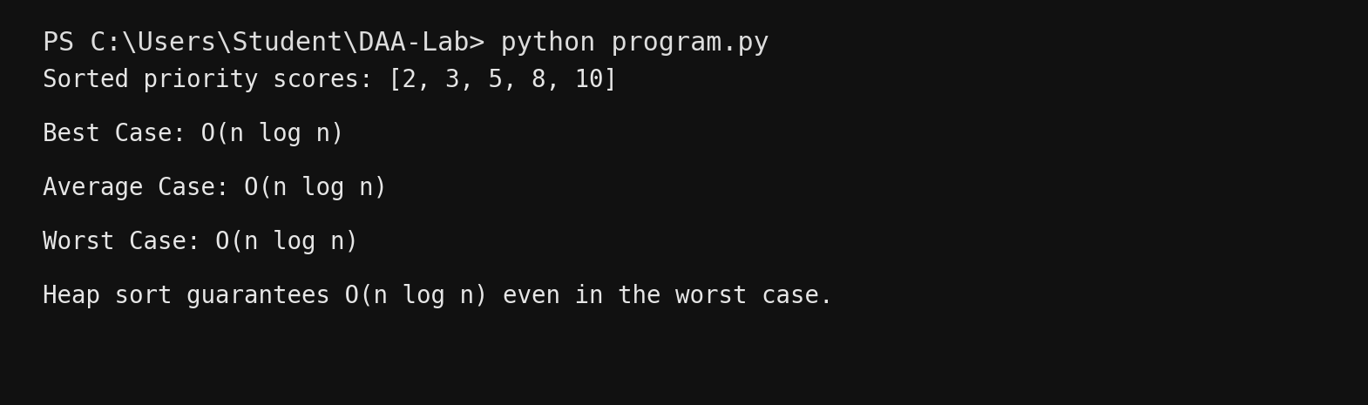

9. Merge Sort
Python Code
def merge_sort(arr):
if len(arr) <= 1:
return arr
mid = len(arr) // 2
left = merge_sort(arr[:mid])
right = merge_sort(arr[mid:])
result = []
i = j = 0
while i < len(left) and j < len(right):
if left[i] <= right[j]:
result.append(left[i])
i += 1
else:
result.append(right[j])
j += 1
result.extend(left[i:])
result.extend(right[j:])
return result
rolls = [105, 101, 110, 103, 102]
rolls = merge_sort(rolls)
print("Sorted master roll list:", rolls)
print("Best Case: O(n log n)")
print("Average Case: O(n log n)")
print("Worst Case: O(n log n)")
print("Merge sort keeps O(n log n) performance for every input arrangement.")
VS Code Terminal Output
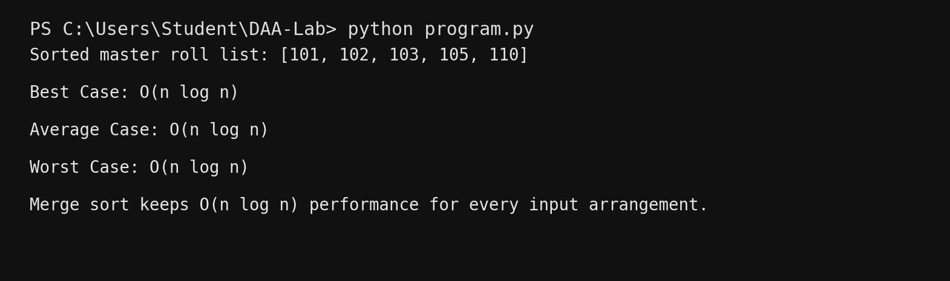

10. Greedy Knapsack (Fractional)
Python Code
def fractional_knapsack(weights, profits, capacity):
items = []
for i in range(len(weights)):
ratio = profits[i] / weights[i]
items.append((ratio, weights[i], profits[i], i + 1))
items.sort(reverse=True)
total_profit = 0
for ratio, weight, profit, number in items:
if capacity >= weight:
capacity -= weight
total_profit += profit
print("Package", number, ": taken fully")
else:
fraction = capacity / weight
total_profit += profit * fraction
print("Package", number, ":", round(fraction * 100, 2), "% taken")
break
return total_profit
weights = [10, 20, 30]
profits = [60, 100, 120]
capacity = 50
profit = fractional_knapsack(weights, profits, capacity)
print("Maximum profit:", profit)
VS Code Terminal Output
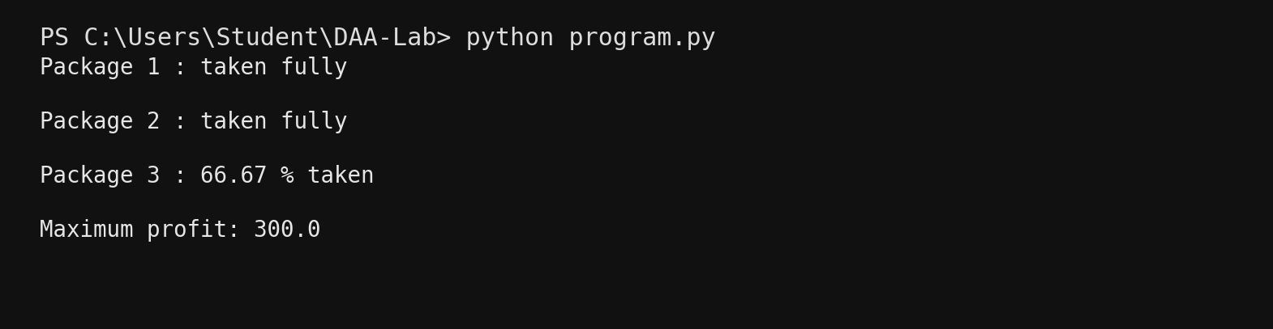

11. Travelling Salesman Problem - Brute Force
Python Code
from itertools import permutations
def tsp(graph):
n = len(graph)
cities = list(range(1, n))
best_cost = float("inf")
best_route = None
for perm in permutations(cities):
route = [0] + list(perm) + [0]
cost = sum(graph[route[i]][route[i + 1]] for i in range(n))
if cost < best_cost:
best_cost = cost
best_route = route
return best_route, best_cost
graph = [
[0, 10, 15, 20],
[10, 0, 35, 25],
[15, 35, 0, 30],
[20, 25, 30, 0]
]
route, cost = tsp(graph)
print("Optimal route:", " -> ".join(str(x + 1) for x in route))
print("Minimum travel cost:", cost)
VS Code Terminal Output
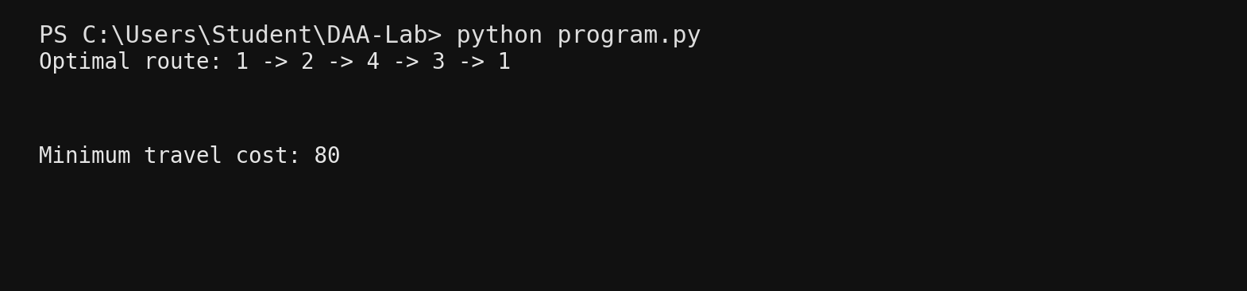

12. Kruskal's Algorithm
Python Code
def find(parent, x):
if parent[x] != x:
parent[x] = find(parent, parent[x])
return parent[x]
def union(parent, rank, a, b):
ra = find(parent, a)
rb = find(parent, b)
if ra == rb:
return False
if rank[ra] < rank[rb]:
parent[ra] = rb
elif rank[ra] > rank[rb]:
parent[rb] = ra
else:
parent[rb] = ra
rank[ra] += 1
return True
def kruskal(vertices, edges):
edges.sort(key=lambda x: x[2])
parent = list(range(vertices))
rank = [0] * vertices
mst = []
cost = 0
for u, v, w in edges:
if union(parent, rank, u, v):
mst.append((u, v, w))
cost += w
return mst, cost
edges = [
(0, 1, 10), (0, 2, 6), (0, 3, 5),
(1, 3, 15), (2, 3, 4)
]
mst, cost = kruskal(4, edges)
print("Edges in MST:")
for u, v, w in mst:
print(u + 1, "-", v + 1, ":", w)
print("Minimum cost:", cost)
VS Code Terminal Output
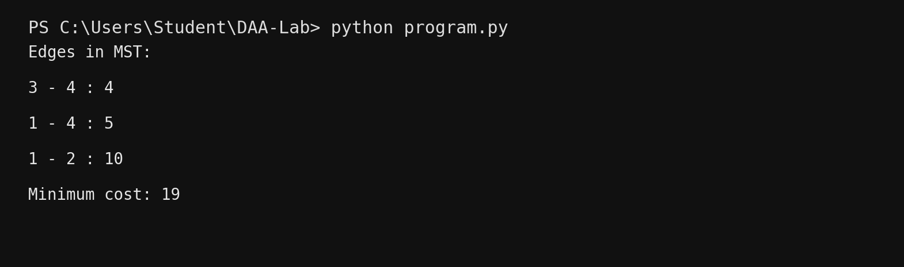

13. N-Queen using Backtracking
Python Code
def solve_n_queen(n):
board = [["." for _ in range(n)] for _ in range(n)]
solutions = []
def safe(row, col):
for r in range(row):
if board[r][col] == "Q":
return False
left = col - (row - r)
right = col + (row - r)
if left >= 0 and board[r][left] == "Q":
return False
if right < n and board[r][right] == "Q":
return False
return True
def backtrack(row):
if row == n:
solutions.append([" ".join(r) for r in board])
return
for col in range(n):
if safe(row, col):
board[row][col] = "Q"
backtrack(row + 1)
board[row][col] = "."
backtrack(0)
return solutions
n = 4
solutions = solve_n_queen(n)
print("Number of solutions:", len(solutions))
print("First solution:")
for row in solutions[0]:
print(row)
VS Code Terminal Output
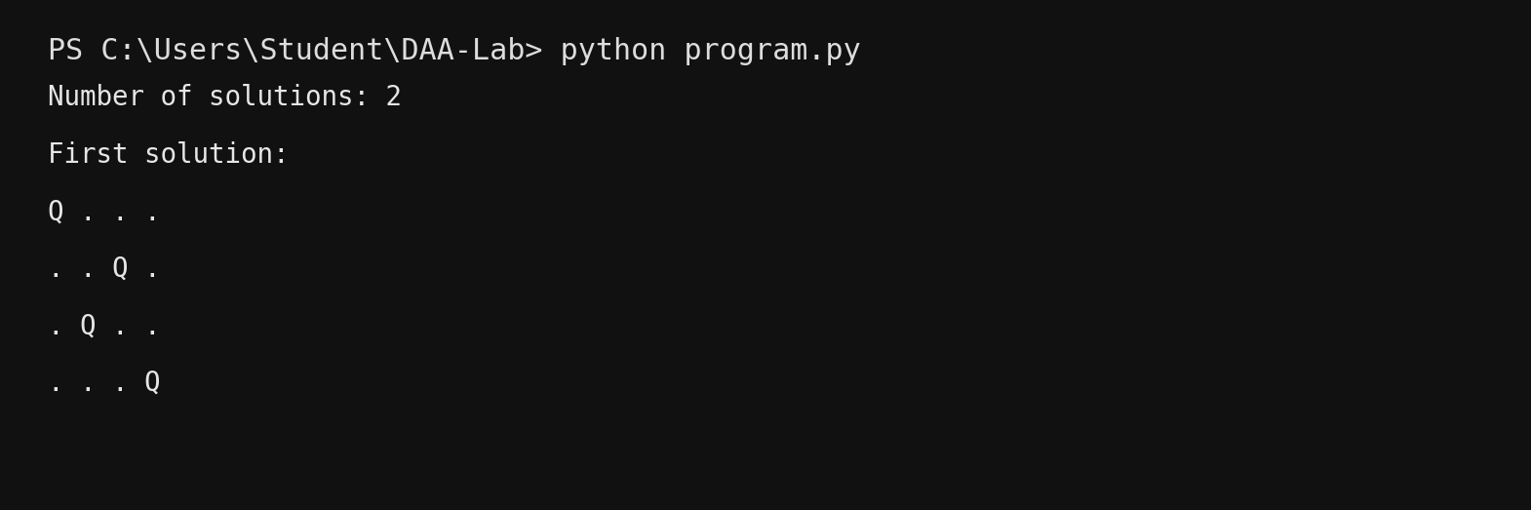

14. 0/1 Knapsack - Dynamic Programming and Greedy
Python Code
def knapsack_dp(weights, profits, capacity):
n = len(weights)
dp = [[0] * (capacity + 1) for _ in range(n + 1)]
for i in range(1, n + 1):
for w in range(capacity + 1):
if weights[i - 1] <= w:
dp[i][w] = max(
dp[i - 1][w],
profits[i - 1] + dp[i - 1][w - weights[i - 1]]
)
else:
dp[i][w] = dp[i - 1][w]
return dp[n][capacity]
def greedy_01(weights, profits, capacity):
items = sorted(
zip(weights, profits),
key=lambda x: x[1] / x[0],
reverse=True
)
total = 0
remaining = capacity
for weight, profit in items:
if weight <= remaining:
remaining -= weight
total += profit
return total
weights = [2, 3, 4, 5]
profits = [3, 4, 5, 6]
capacity = 5
print("DP maximum profit:", knapsack_dp(weights, profits, capacity))
print("Greedy 0/1 result:", greedy_01(weights, profits, capacity))
print("Note: Greedy is not guaranteed to give the optimal 0/1 knapsack solution.")
VS Code Terminal Output
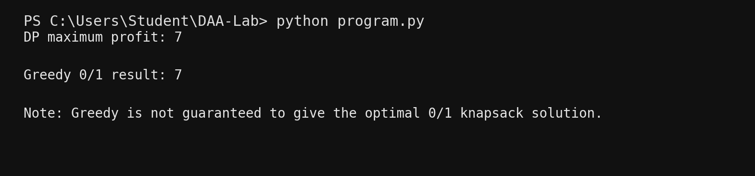

15. Dijkstra's Algorithm
Python Code
import heapq
def dijkstra(graph, start):
dist = [float("inf")] * len(graph)
dist[start] = 0
pq = [(0, start)]
while pq:
current_dist, u = heapq.heappop(pq)
if current_dist != dist[u]:
continue
for v, weight in graph[u]:
new_dist = current_dist + weight
if new_dist < dist[v]:
dist[v] = new_dist
heapq.heappush(pq, (new_dist, v))
return dist
graph = [
[(1, 4), (2, 1)],
[(3, 1)],
[(1, 2), (3, 5)],
[]
]
distances = dijkstra(graph, 0)
print("Shortest distances from vertex 1:")
for i, d in enumerate(distances):
print("To vertex", i + 1, "=", d)
VS Code Terminal Output
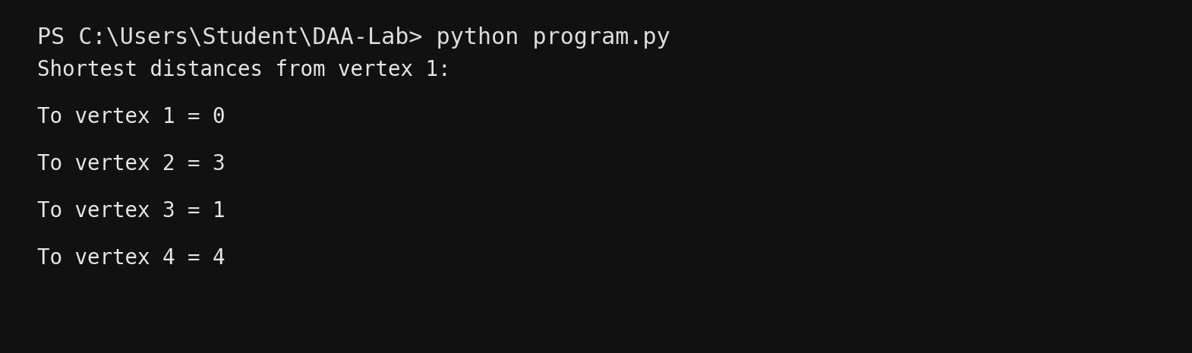

16. Subset Sum using Backtracking
Python Code
def subset_sum(arr, target):
solutions = []
def backtrack(index, current, total):
if total == target:
solutions.append(current[:])
return
if index == len(arr) or total > target:
return
current.append(arr[index])
backtrack(index + 1, current, total + arr[index])
current.pop()
backtrack(index + 1, current, total)
backtrack(0, [], 0)
return solutions
S = [1, 2, 5, 6, 8]
d = 9
solutions = subset_sum(S, d)
if solutions:
print("Subsets with sum", d, ":")
for s in solutions:
print(s)
else:
print("No solution exists.")
VS Code Terminal Output
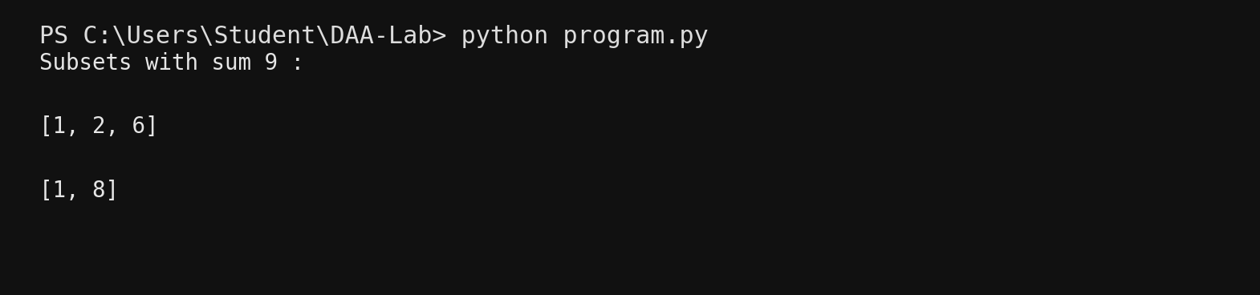

17. Hamiltonian Cycles using Backtracking
Python Code
def hamiltonian_cycles(graph):
n = len(graph)
path = [0]
cycles = []
def safe(v):
if graph[path[-1]][v] == 0:
return False
if v in path:
return False
return True
def backtrack():
if len(path) == n:
if graph[path[-1]][path[0]] != 0:
cycles.append(path[:] + [path[0]])
return
for v in range(1, n):
if safe(v):
path.append(v)
backtrack()
path.pop()
backtrack()
return cycles
graph = [
[0, 1, 1, 1],
[1, 0, 1, 1],
[1, 1, 0, 1],
[1, 1, 1, 0]
]
cycles = hamiltonian_cycles(graph)
print("Hamiltonian cycles:")
for cycle in cycles[:3]:
print(" -> ".join(str(v + 1) for v in cycle))
print("Total cycles found:", len(cycles))
VS Code Terminal Output
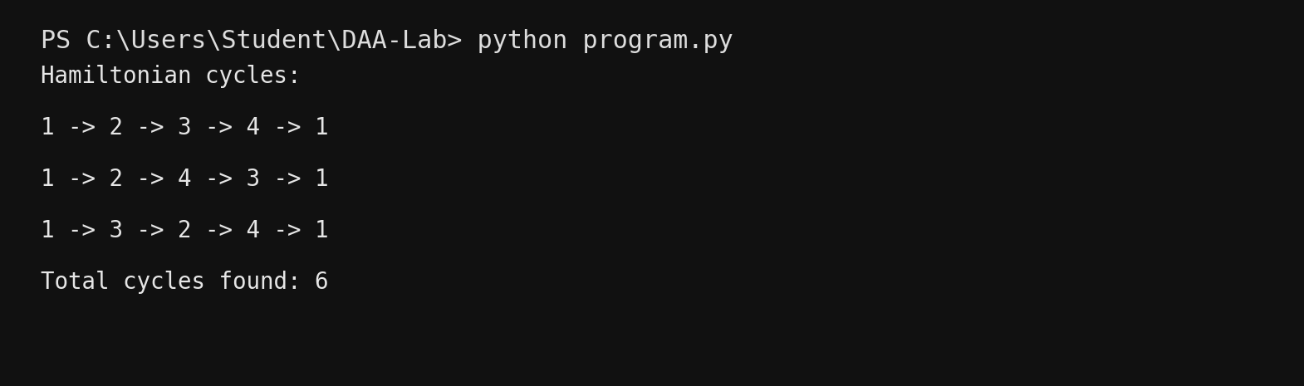

18(a). Floyd's All-Pairs Shortest Paths
Python Code
INF = 999
graph = [
[0, 3, INF, 7],
[8, 0, 2, INF],
[5, INF, 0, 1],
[2, INF, INF, 0]
]
n = len(graph)
dist = [row[:] for row in graph]
for k in range(n):
for i in range(n):
for j in range(n):
dist[i][j] = min(dist[i][j],
dist[i][k] + dist[k][j])
print("All-Pairs Shortest Path matrix:")
for row in dist:
print(row)
print("Time Complexity: O(n^3)")
VS Code Terminal Output
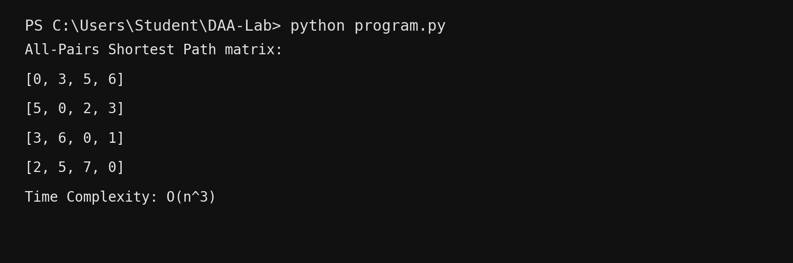

18(b). Travelling Salesman - Dynamic Programming
Python Code
from functools import lru_cache
def tsp_dp(graph):
n = len(graph)
@lru_cache(None)
def dp(mask, pos):
if mask == (1 << n) - 1:
return graph[pos][0]
ans = float("inf")
for city in range(n):
if not (mask & (1 << city)):
ans = min(ans,
graph[pos][city] +
dp(mask | (1 << city), city))
return ans
return dp(1, 0)
graph = [
[0, 10, 15, 20],
[10, 0, 35, 25],
[15, 35, 0, 30],
[20, 25, 30, 0]
]
print("Minimum TSP cost using DP:", tsp_dp(graph))
print("Time Complexity: O(n^2 * 2^n)")
VS Code Terminal Output
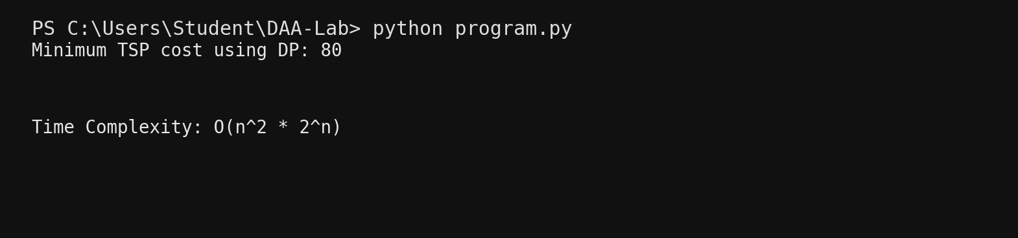

19. Prim's Algorithm
Python Code
import heapq
def prim(graph):
n = len(graph)
visited = [False] * n
pq = [(0, 0, -1)]
mst = []
cost = 0
while pq and len(mst) < n - 1:
weight, u, parent = heapq.heappop(pq)
if visited[u]:
continue
visited[u] = True
if parent != -1:
mst.append((parent, u, weight))
cost += weight
for v, w in graph[u]:
if not visited[v]:
heapq.heappush(pq, (w, v, u))
return mst, cost
graph = [
[(1, 10), (2, 6), (3, 5)],
[(0, 10), (3, 15)],
[(0, 6), (3, 4)],
[(0, 5), (1, 15), (2, 4)]
]
mst, cost = prim(graph)
print("Edges in MST:")
for u, v, w in mst:
print(u + 1, "-", v + 1, ":", w)
print("Minimum cost:", cost)
VS Code Terminal Output


